|  |  |
| --- | --- |
| **Name** | **Enayathulla A** |
| **Date** | **09/01/2024** |
| **Type** | **Daily Assignment** |
| **Topic** | **Creating Repo on Azure DevOps** |

**Creating Repo on Azure DevOps:**

Step1🡺 Login into Azure portal and search **Azure DevOps Organizations**

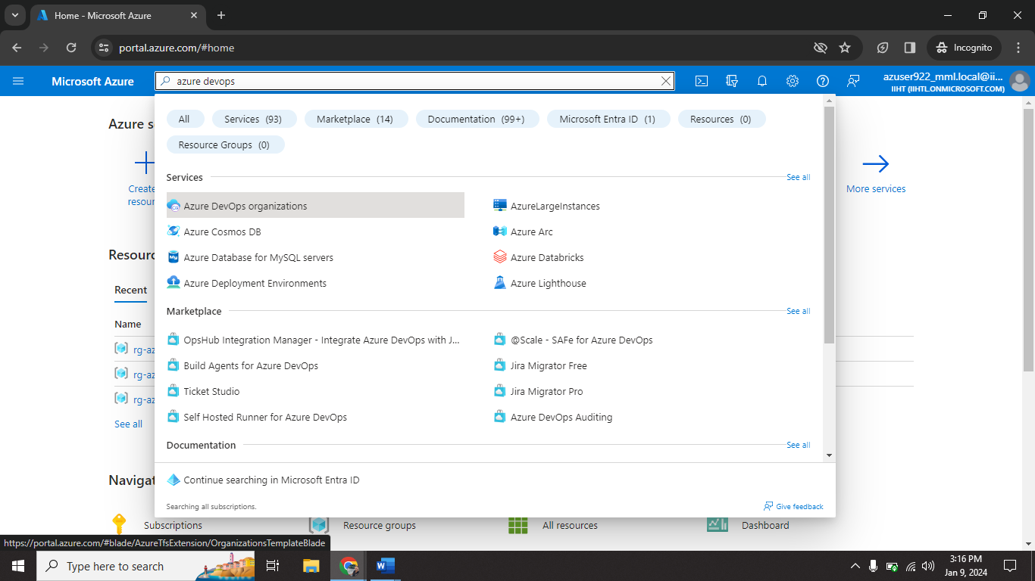

Step2🡺 click on **My Azure DevOps Organizations**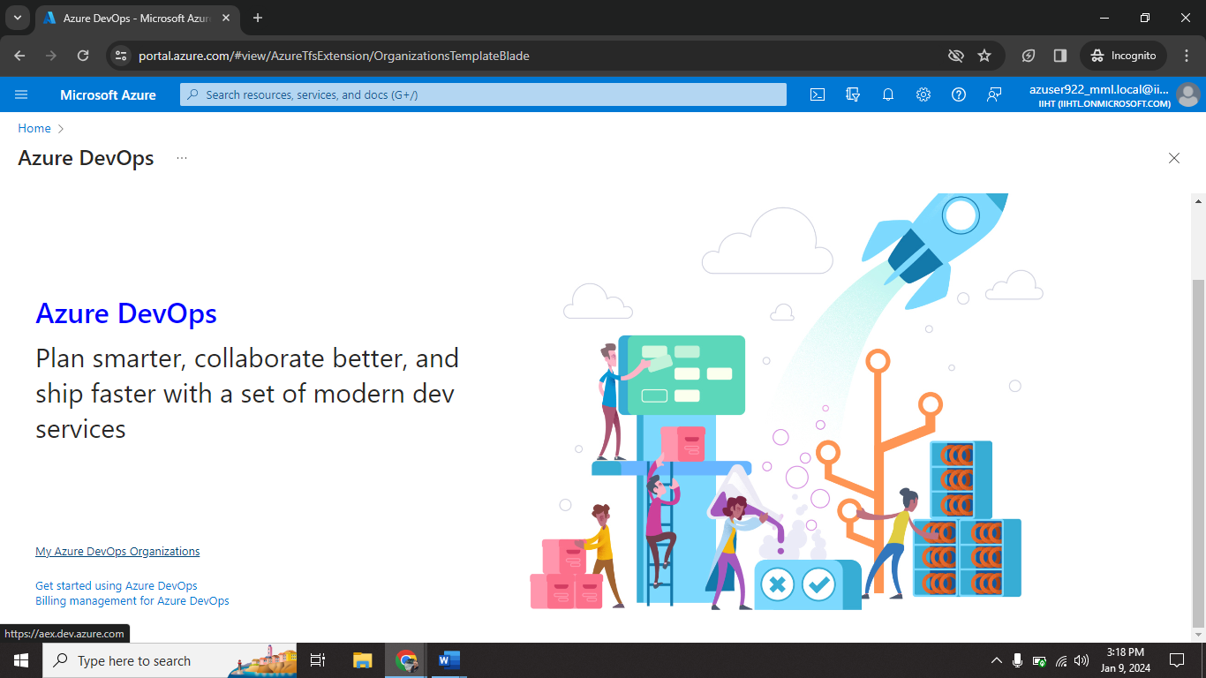

Step3🡺 Give your details and click on **Continue**

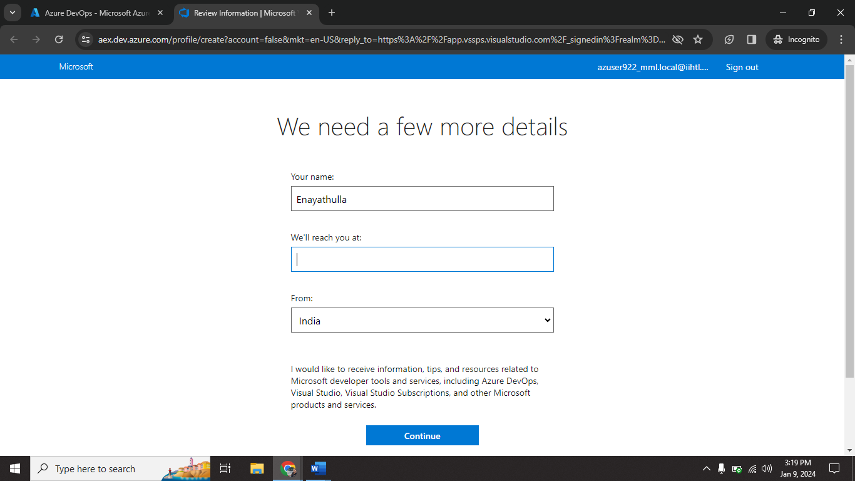

Step4🡺I give organization name (Enayathulla-BIBA) and select host location (India).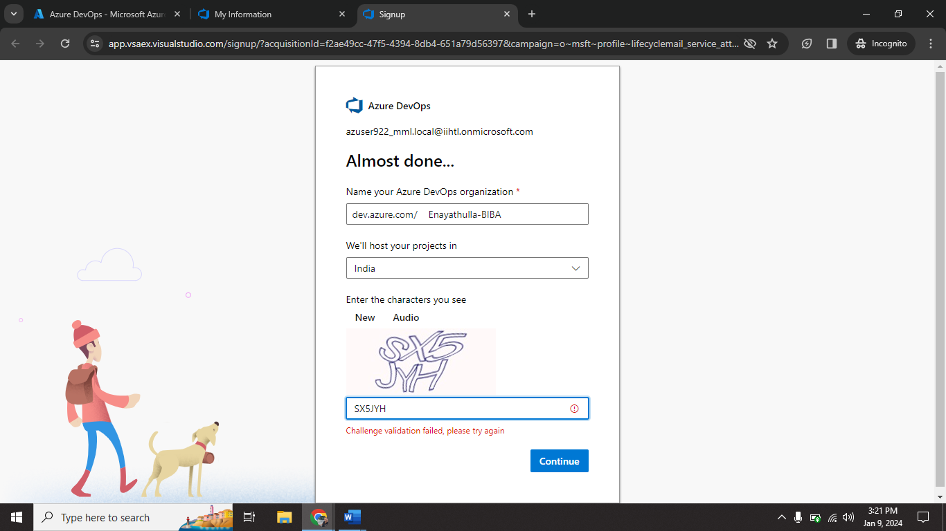

Step5🡺Now enter Project name (Enayathulla-Project) and type (Private).

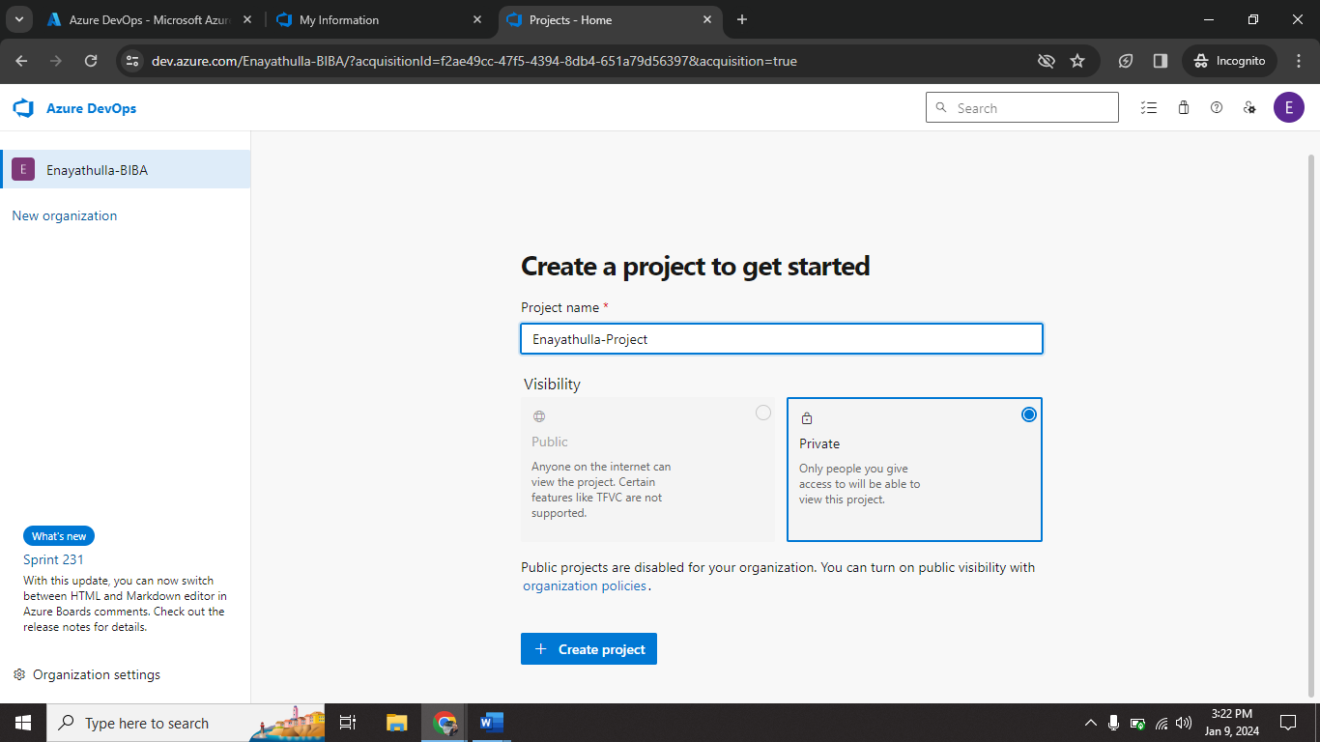

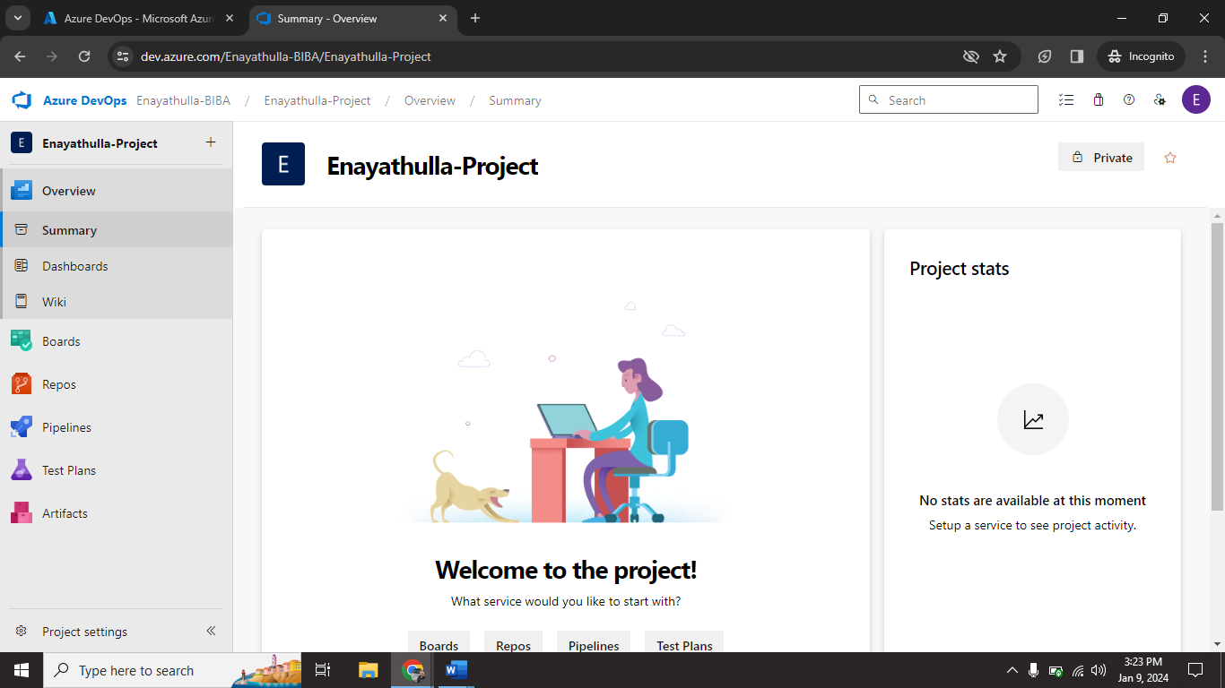

Step6🡺 click on **New repository.**

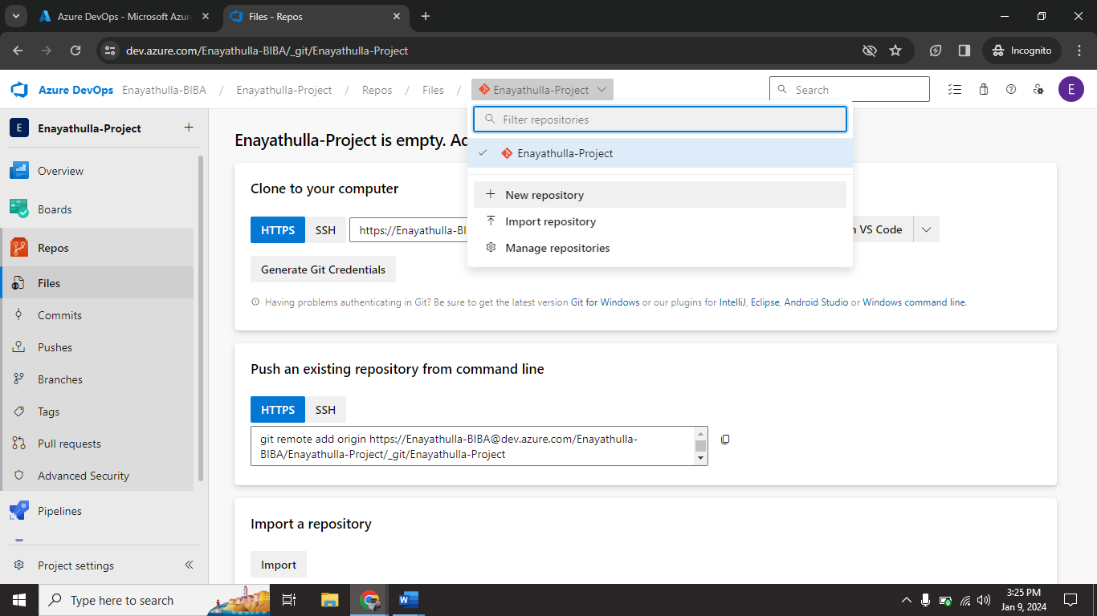

Step7🡺 give the repository name (Enayathulla-Sample 1).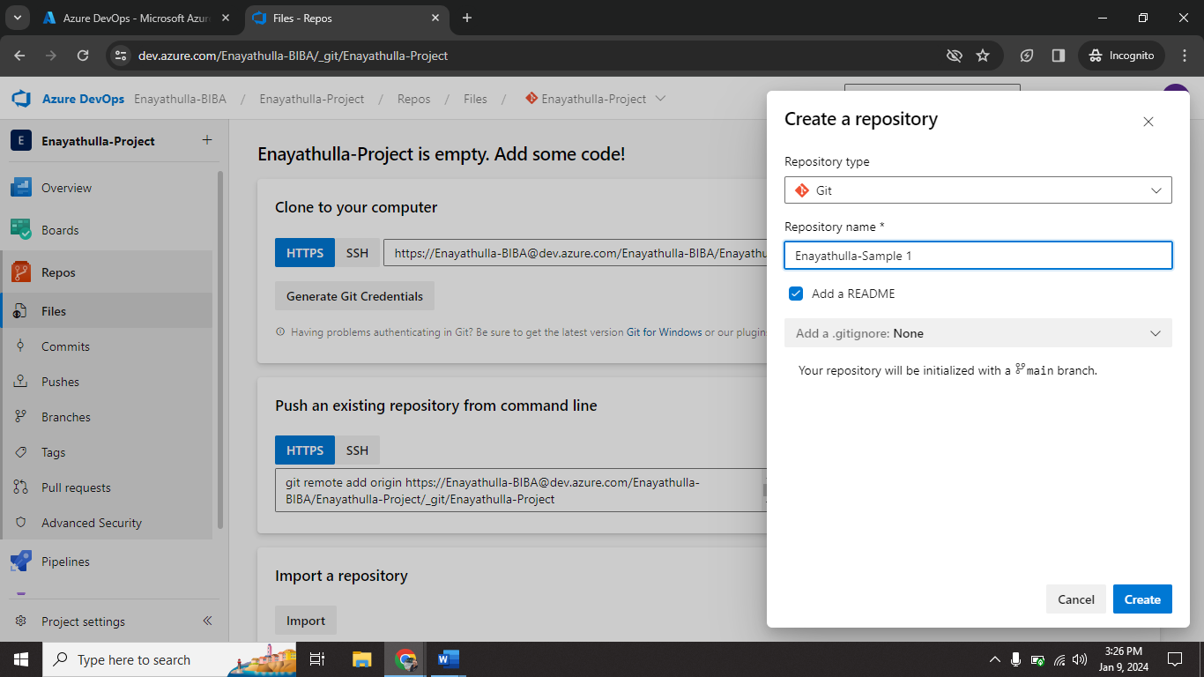

Step8🡺 click on **Clone.**

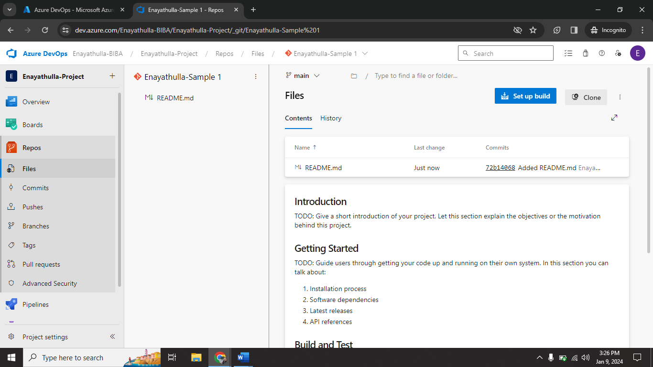

Step9🡺 click on **Clone in VS Code.**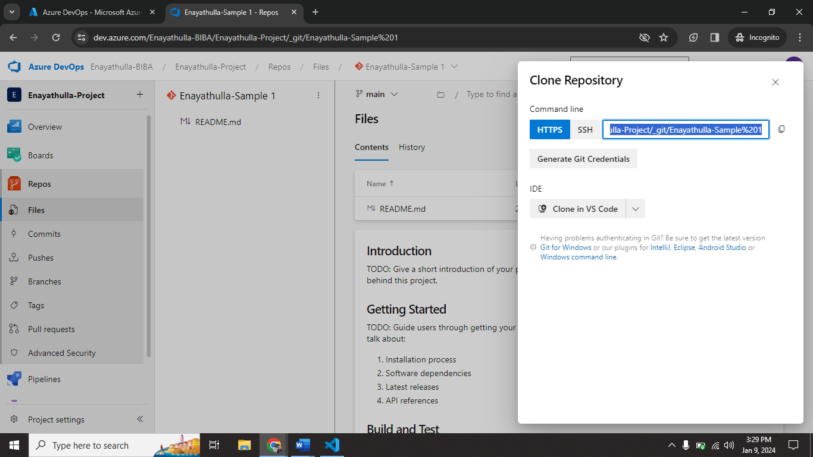

Step10🡺 cloning process done on VS Code.

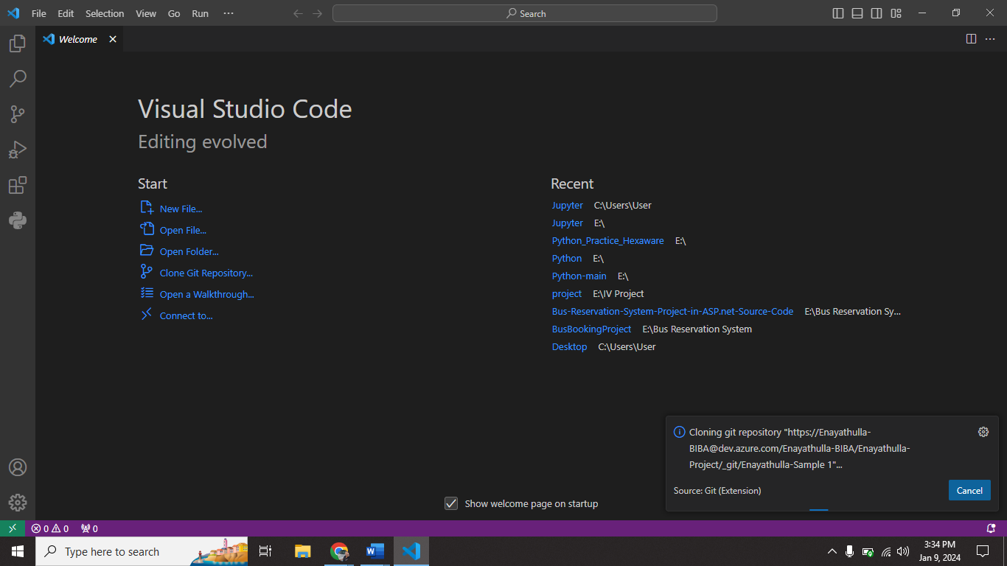

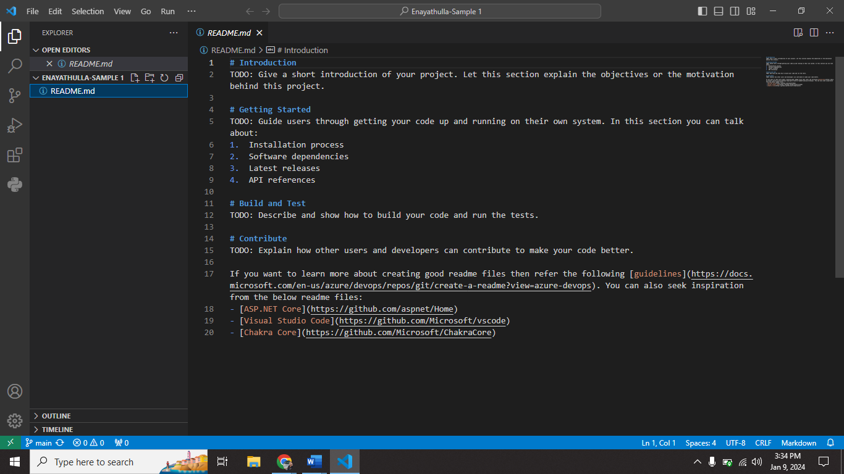

Step11🡺create new file (new.py) on VS Code.

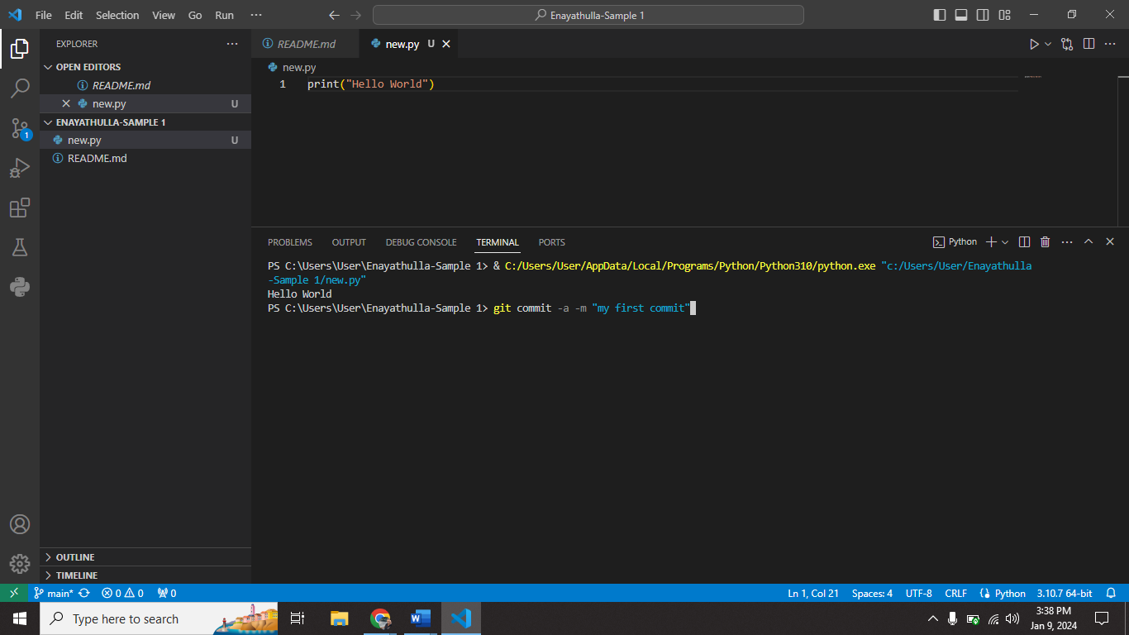

Step12🡺Open git bash and enter the commands (on repository location).

1. git add new.py
2. git commit -a -m “my first commit”
3. git push

Step13🡺 go to History tab you can see your commit.

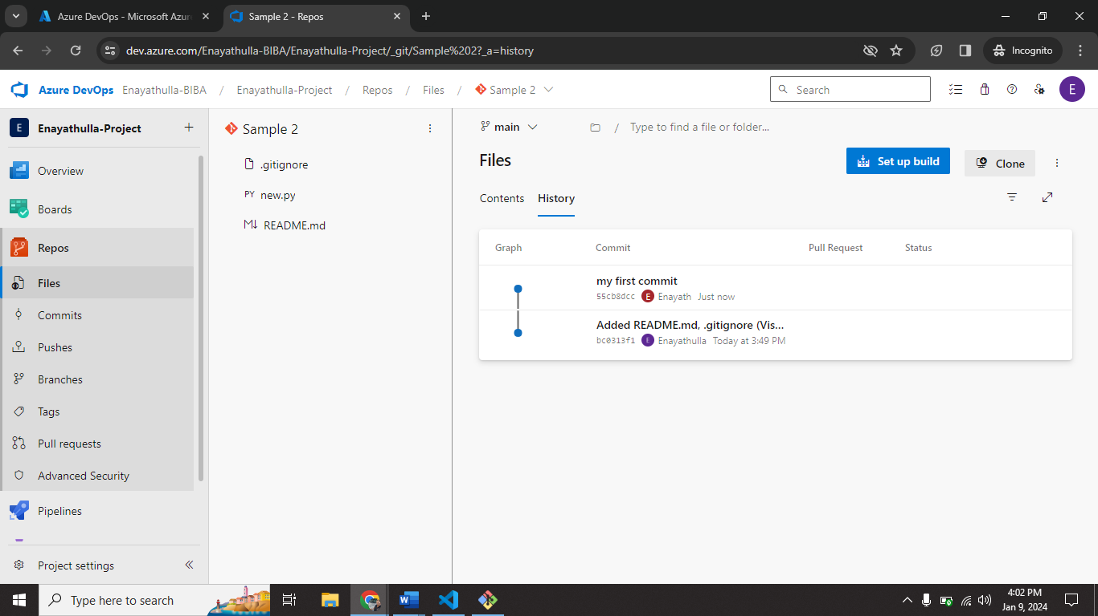

Step14🡺 After completing all the task. Go to **Organization Setting** select **Delete Organization.**

